Types of motherboard:

1. AT motherboard
2. ATX motherboard
3. BTX motherboard
4. LPX motherboard

**AT Motherboard**

An AT motherboard is a motherboard which has dimensions of the order of some hundred millimeters, big enough to be unable to fit in mini desktops. The dimensions of this motherboard make it difficult for the new drives to get installed. The concept of six pin plugs and sockets is used so as to work as the power connectors for this type of motherboards.

The hard to distinguish power connector sockets make it difficult for many users to easily make the proper connections and thus leading to the damage of the device.

Produced in the mid 80’s, this motherboard lasted a good span from the Pentium p5 to the times when Pentium 2 had been started to be used.

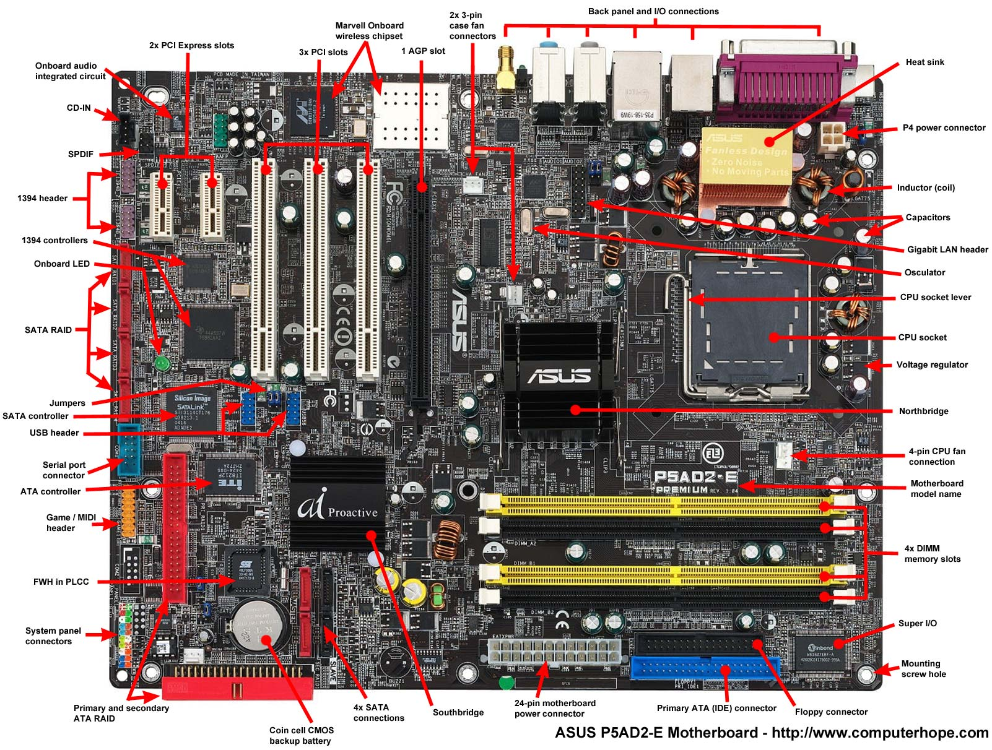

## ATX Motherboard

Advanced technology extended, or popularly known as the ATX, are the motherboards which were produced by the Intel in mid 90’s as an improvement from the previously working motherboards such as AT.

This type of motherboards differ from their AT counterparts in the way that these motherboards allow the interchangeability of the connected parts. Moreover the dimensions of this motherboard are smaller than the AT motherboards and thus proper place for the drive bays is also allowed.

Some good changes were also made to the connector system of the board. The AT motherboards had a keyboard connector and on the back plates extra slots were provided for various add-ons.

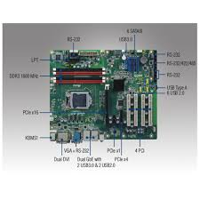

**BTX Motherboard**

BTX stands for Balanced Technology extended.

BTX was developed to reduce or avoid some of the issues that came up while using latest technologies. Newer technologies often demand more power and they also release more heat when implemented on motherboards in accordance with the circa-1996 ATX specification. The ATX standard and the BTX standard, both were proposed by Intel. The further development of BTX retail products was canceled in September 2006 by Intel after the acceptance of Intel’s decision to focus again on low-power CPUs after suffering issues such as scaling and thermal with the Pentium 4.

* Low-profile – With the larger demand for ever-smaller systems, a redesigned backplane that shaves inches off the height requirements is a benefit to system integrators and enterprises which use rack mounts or blade servers.
* Thermal design – The BTX design provides a straighter path of airflow with lesser difficulties, which results in better overall cooling capabilities. Instead of a dedicated cooling fan, a large 12 cm case-fan is mounted, that draws its air directly from outside the computer and then cools the CPU through an air duct. Another feature of BTX is the vertical mounting of the motherboard on the left-hand side. This kind of feature results in the graphics card heat sink or fan facing upwards, rather than in the direction of the adjacent expansion card.
* Structural design – The BTX standard specifies distinct locations for hardware mounting points and hence reduces latency between key components. It also reduces the physical strain imposed on the motherboard by heat sinks, capacitors and other components which are dealing with electrical and thermal regulation. 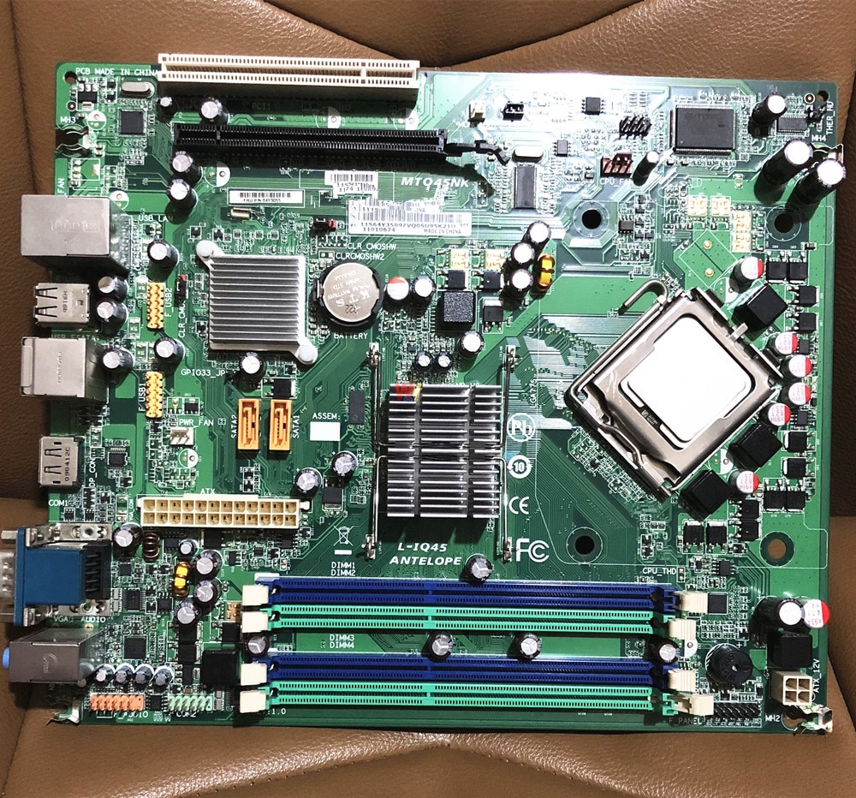

## LPX Motherboard

The low profile extension motherboards, better known as LPX motherboards, were created after the AT boards in the 90’s.

The major difference between these and previous boards is that the input and output ports in these boards are present at the back of the system. This concept proved to be beneficial and was also adopted by the AT boards in their newer versions. The use of a riser card was also made for the placement of some more slots. But these riser cards also posed a problem that the air flow was not  proper.

Also, some low quality LPX boards didn’t even have real AGP slot and simply connected to the PCI bus. All these unfavored aspects led to the extinction of this motherboard system and was succeeded by the NLX.